- Login to agent dashboard https://agent.staging.cakap.com/dashboard , must use acc squlinexjanine / staging123456, stay on menu dashboard
- Or use Agent it must have role Influencer 15, you can set on this menu for the account agent https://legacy-admin-staging.cakap.com/agent/en/agent/get_agent/all/all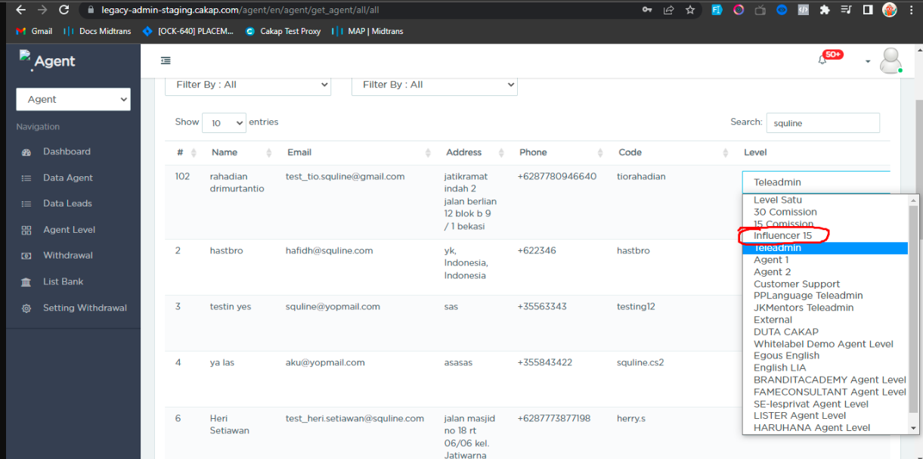
- Click call on teacher dashboard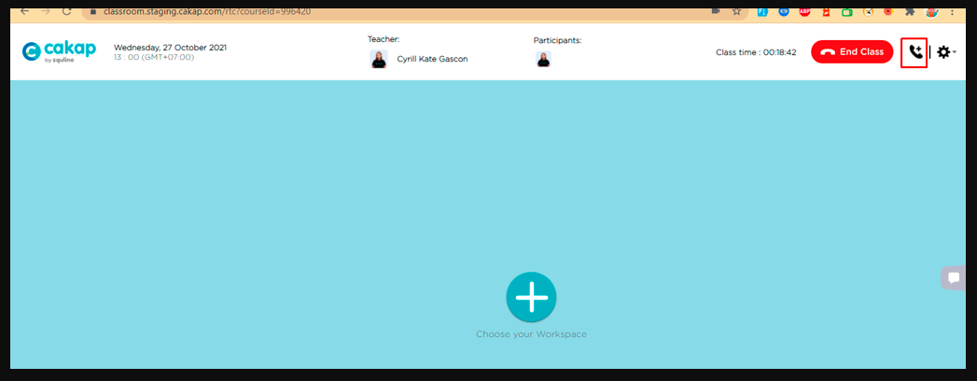
- Click call on teacher dashboard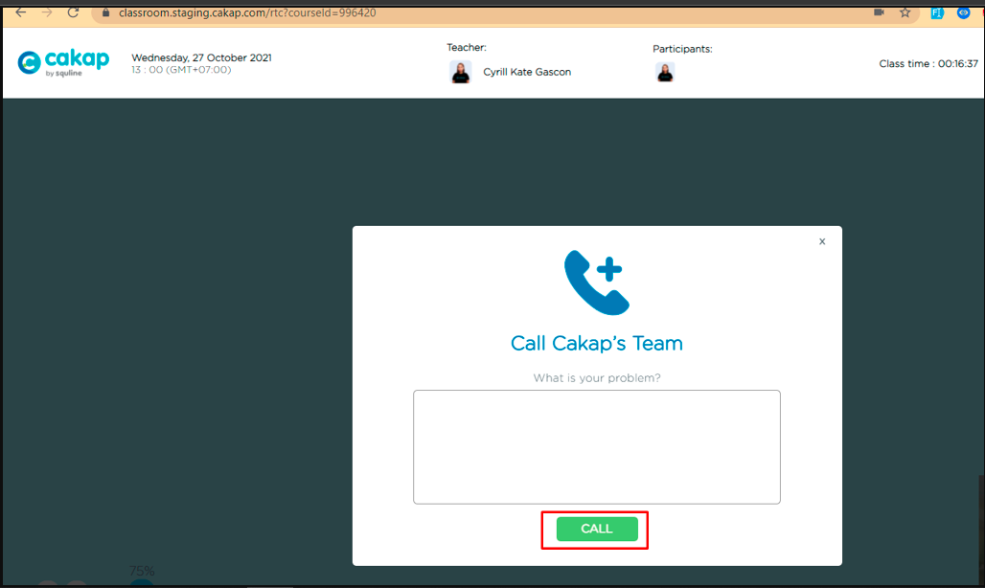
- Go to agent , show on buttom left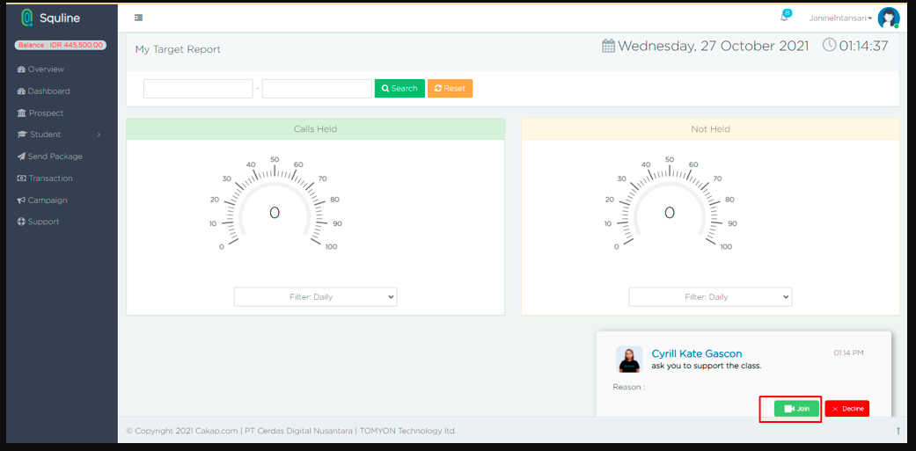
- Click button join , for join to the class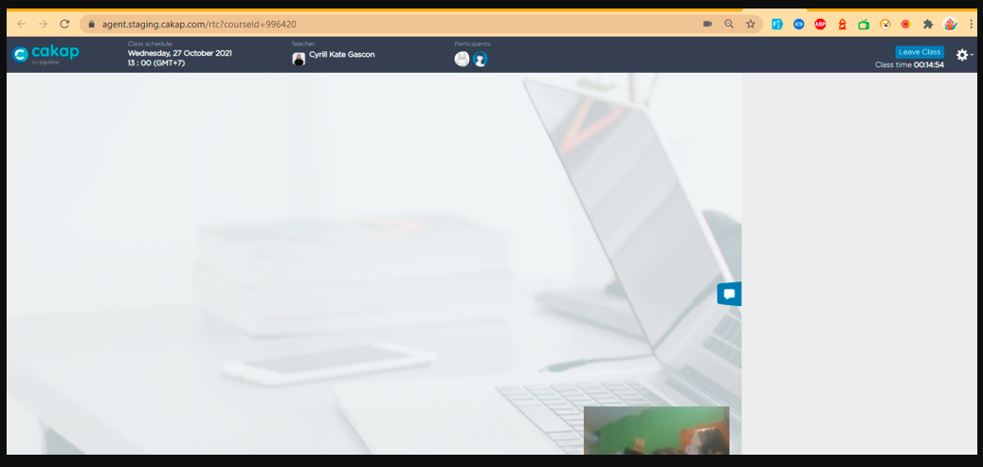
Agent role :
- agent just can send chat
- agent just can on send audio
- agent cant on cam
- agent just can see cam from teacher
- cam agent is not show with anything between teacher or student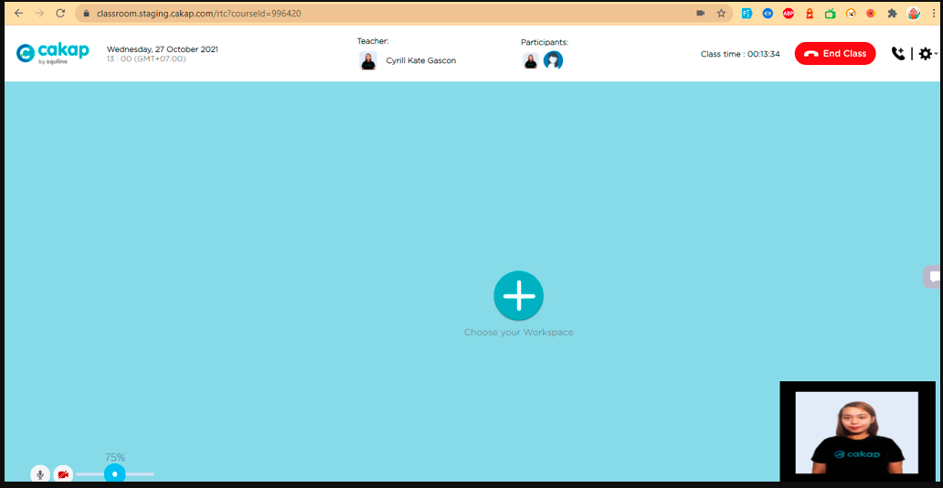
- Agent can see sharescreen from teacher